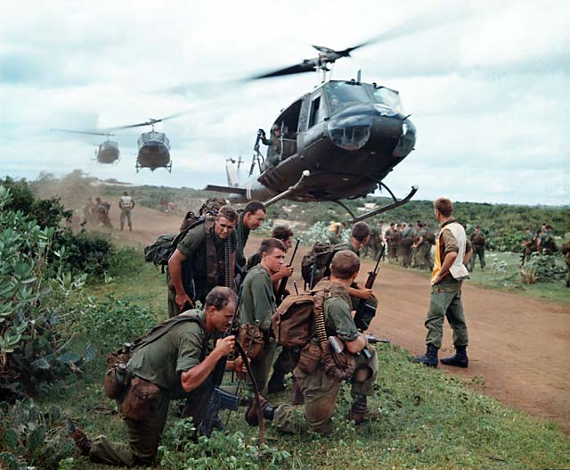
HL90ak
Steven Biel
Jeanne Follansbee
Fall 2012
Wednesday, 3-5
Barker 128

The Vietnam War in American Culture
“Could Afghanistan be Obama’s Vietnam?” a Newsweek columnist asked in January 2009 when he considered the relevance of the “Vietnam analogy” in his assessment of Obama’s escalation of the war in Afghanistan. As we approach the 50th anniversary of the Gulf of Tonkin Resolution, this course will examine the U.S. war in Vietnam from the 1950s through the fall of Saigon, and its legacies up to the present. Considering a range of texts by and about soldiers and veterans, policy makers and protesters, reporters and refugees, the course covers key events in the war, as well as representations and reinterpretations of these events in later years. In each week, we have paired materials produced during the war with those produced after the war in order to explore Americans’ contested and changing understandings of the experiences and meanings of the Vietnam War. Texts include popular films, documentaries, journalism, fiction, letters, diaries, government documents, and war memorials.

Course Requirements
This is a seminar. Students are expected to come to class prepared for discussion about the materials assigned each week. In addition, students will write two papers and complete a take home final exam.

Class Participation 20%
Paper One (5-7 pages) 20%
Paper Two (8-10 pages) 30%
Take Home Exam 30%

Course Texts:
Texts marked with an asterisk (*) are available for purchase at the Harvard Coop. All films are on reserve at Lamont. Other materials are available on the course iSite.

Readings and Due Dates:

September 5:
Introduction

September 12:
What Kind of War is This?: From World War to Guerrilla War

Peter Davis (dir), Hearts and Minds (1974)
*Larry Addington, America’s War In Vietnam: A Short Narrative History (2000)
Garry Wills, John Wayne’s America, (1998), Chapter 18
Optional: John Wayne and Ray Kellogg (dir), The Green Berets (1968)

September 19:
Exit the French: American Anti-Communism in 1950s Vietnam

*Graham Greene, The Quiet American (1955)
Joseph L. Mankiewicz (dir), The Quiet American (1958)
Frances Fitzgerald, “Marxism-Leninism in the Vietnam Landscape,” in Fire in the Lake: The Vietnamese and the Americans in Vietnam (1972), pp. 212-227

September 26:
Camaraderie and Alienation: Representing Combat

*Michael Herr, Dispatches (1977)
Francis Ford Coppola (dir), Apocalypse Now (1979)
Optional: Fax Bahr and George Hickenlooper (dirs.), Hearts of Darkness (1991)

October 3:
“Humping the Boonies”: Grunts and the Vietnam War

Bernard Edelman, ed., Dear America: Letters Home From Vietnam (1985), chapter 2
*Tim O’Brien, The Things They Carried (1990)
Oliver Stone (dir.), Platoon (1986)

October 8 (MONDAY): Paper One Due at 4 p.m. (History and Literature Office)

October 10:
“We Gotta Get Outta This Place”: Class, Race, and the Draft

Stewart Alsop, “Fairness and the Draft” (1970), in Reporting Vietnam: American Journalism, 1959-1975 (1998), pp. 463-466
Thomas A. Johnson, “Black Servicemen and the War” (1968), in Reporting Vietnam, pp. 349-361
Wallace Terry, “Racial Tensions in the Military” (1969), in Reporting Vietnam, pp. 396-400
Michael Cimino (dir), The Deer Hunter (1979)
*Christian Appy, Working Class War: American Combat Soldiers and Vietnam (1993)

October 17:
Protesting the War

*Norman Mailer, Armies of the Night (1967)
Glenn Silber and Barry Alexander Brown (dirs), The War at Home (1979)
Barbara Tischler, “The Anti-War Movement” (2002), in Marilyn B. Young and Robert Buzzanco, eds., A Companion to the Vietnam War (2002), pp. 384-402

October 24:
The My Lai Massacre

Seymour Hersh, “An Atrocity is Uncovered” (1969), in Reporting Vietnam, pp. 413-427
*Tim O’Brien, In the Lake of the Woods (1994)
*James S. Olson and Randy Roberts, eds., My Lai: A Brief History with Documents (1998)

October 31:
“The Best and The Brightest”: Policymaking and the Vietnam War

David Halberstam, The Best and the Brightest (1972), Chapter 4
*George C. Herring, ed., The Pentagon Papers (1993)
Errol Morris (dir), The Fog of War (2004)
Robert Dean, “’They’ll Forgive You for Anything Except Being Weak’: Gender and U.S. Escalation in Vietnam, 1961-1965 (2002), in A Companion to the Vietnam War, pp. 367-383

November 7:
“Are They Going to Let Us Win This Time?”: POWs and the Work of Commemoration

Zalin Grant, Survivors: Vietnam POWs Tell Their Stories (1975), Chapters 14-16
George Cosmatos (dir), Rambo: First Blood Part II (1985)
Craig Howes, Voices of the Vietnam POWs: Witnesses to Their Fight (1993), Chapters 1-3
*Kristen Haas, Carried to the Wall (1998)

November 14:
Coming Home: Domesticating the War

*Bobbie Ann Mason, In Country (1985)
Hal Ashby (dir), Coming Home (1978)
*Myra MacPherson, Long Time Passing: Vietnam and the Haunted Generation (2002),
Parts III; IV; VII, Chapter 6

November 19 (MONDAY): Paper Two Due at 4 p.m. (History and Literature Office)

November 28:
Dreaming of Peace: Women and the Vietnam War

*Last Night I Dreamed of Peace: The Diary of Dang Thuy Tram (2007)
Barbara Sonnenborn (dir), Regret to Inform (1998)
*MacPherson, Long Time Passing, Part VI

December 5:
Remembering Vietnam: Stories of Vietnamese Refugees

Nam Le, “Love and Honor and Pity and Pride and Compassion and
Sacrifice” in The Boat (2008)
*Lan Cao, Monkey Bridge (1997)

December 7 (FRIDAY): Pick Up Take Home Exam (History and Literature Office)

December 10 (MONDAY): Take Home Exam Due (History and Literature Office)

